

A

PROJECT REPORT ON

**“My EShoppingWebsite”**

**Submitted to,**

**SHIVAJI UNIVERSITY, KOLHAPUR.**

**Submitted as partial fulfillment of the of requirement**

**“BACHELOR OF COMPUTER APPLICATIONS” (B.C.A-III) SEM-VI**

**Submitted BY**-

1. **Kumail Abass**

**2. Abrar Nisar Sayyad**

**UNDER THE GUIDANCE OF:**

**Mrs. Komal Chaudhari**

**THE PRINCIPAL**

**JANATA SHIKSHAN SANSTHA**

**KISAN VEER MAHAVIDYALAYA WAI**

**DEPARTMENT OF BCA**

**YEAR**

**(2023-2024)**

**JANATA SHIKSHAN SANSTHA**

**KISAN VEER MAHAVIDYALAYA WAI**



**CERTIFICATE**

This is to certify that project report entitled “Grocery Shop Managemnet System” Submitted by Mr. Kumail Abass , Mr. Abrar Nisar Sayyad in partial fulfilment of the requirement for the award of Bachlor of Computer Application (Sem-VI) Shivaji University,Kolhapur has been carried out by them under the guidance of **Mrs. Komal Chaudhari.**

To the best my knowledge and belief, this is his original work and the matter presented in this project has not submitted earlier

Project Guide External Examiner

# Declaration

To,

The Principal, Kisan Veer Mahavidyala, Wai.

Respected sir,

We undersigned hereby declare that the project entitled “**MyEShopping Website**”. developed and submitted under the guidance of **Mrs. Komal Chaudhari This** is our original work. The empirical finding in this project is based on the data collection by us. while preparing

this project. We have not copied from any other project report.

we understand that, any such copying is liable to punished in a way the center university authorities may be deem it.

Date: - Place:-Wai

**Yours sincerely**

1  **Mr. Kumail Abass**

2. **Mr. Abrar Nisar Sayyad**

## ACKNOWLEDGEMENT

It is great immense Satisfaction to express our deepest sense of gratitude and thanks to everyone who has directly or indirectly helped us to complete project successful.

We express our deepest sense of gratitude to **Mrs. ARCHANA KADAM who** is rendered valuable guidance and perceptual encouragement in completing project works successfully in the Schedule time and for providing us all facilities to carry the project work. We are also thankful teaching and non- teaching staff of computer Department.

We sincerely thanks to computer Department faculty members for their time to time help during project work. Without the help of our colleagues and classmates this project would not have been completed.

Last but not least, we indebted to our parents for their encouragement and help in building of our carrier.

**Yours sincerely**

1 **Mr. Kumail Abass**

2. **Mr. Abrar Nisar Sayyad**

**INDEX**

|  |  |  |
| --- | --- | --- |
| **Sr.no.** | **Title** | **Page no** |
| **1** | **Introduction to project:**   * 1. Introduction   2. Existing System   3. Need and scope of computer system |  |
| **2** | **SOFTWAREREQMENTSPECIFICATION**  2.1) Requirement gathering 2.2) proposed System  2.3) Questionnaires |  |
| **3** | **REQUIREMENT**  3.1) Hardware  3.2) Software |  |
| **4** | **SYSTEM ANALYSIS**   * 1. DFD   2. ERD |  |
| **5** | **SYSTEM DESIGN**  5.1) Database Design |  |
| **6** | **USER INTERFACE DESIGN**    6.1) Forms  6.2) Reports |  |
| **7** | **LIMITATIONS** |  |
| **8** | **FUTURE MODIFICATION** |  |
| **9** | **CONCLUSION** |  |
| **10** | **BIBLIOGRAPHY** |  |

**INTRODUCTION**

The “MyEShoppingWebsite” has been developed to override the problems prevailing in the practicing manual system. This software is supported to eliminate and, in some cases, reduce the hardships faced by this existing system. Moreover, this system is designed for the particular need of the company to carry out operations in a smooth and effective manner. The application is reduced as much as possible to avoid errors while entering the data. It also provides error message while entering invalid data. Now formal knowledge is needed for the user to use this system. Thus, by this all it proves it is user-friendly. MyEShoppingWebsite, as described above, can need to error free, secure, reliable and fast management system. It can assist the user to concentrate on their other activities rather to concentrate on the record keeping. Thus, it will help organization in better utilization of resources. Every organization, whether big or small, has challenges to overcome and managing the information of item Category, products, Customer, Delivery Address, Order. Every MyEShoppingWebsite has different product needs, therefore

we design exclusive user management systems that are adapted to your managerial requirements. This is designed to assist in strategic planning, and will help you ensure that your organization is equipped with the right level of information and details for your future goals. Also, for those busy executive who are always on the go, our systems come with remote access features, which will allow you to manage your workforce anytime, at all times. These systems will ultimately allow you to better manage resources.

**INTRODUCTION OF EXISTING SYSTEM**

**MANUAL SYSTEM: -**

Manual system of MyEShoppingWebsite involves customers placing order over the phone or in person at a restaurant

1. Customer visits the Website to place an order.
2. Customer provides their order details and address.
3. Customer provide its address and details.
4. Payment is made either through online payment applications, or cash on delivery.
5. Vendor sends the item to the customer through transportation.
6. Customer picks up the order or has it delivered to their location and pay if it is not prepaid(Cash on delivery).

## NEED FOR COMPUTERIZATIAON: -

1. Website will be globally access by everyone.
2. To provide 24*7 easy access.

3) Reduce the work of paper.

4) No loss of data as like paper-based data.

5) It will help in register online from anywhere no need to come at main office.

6) Save time, money and paper

. 7) Use of new technologies.

**INTRODUCTION TO ORGANIZATION PROFILE**

* Name: - MyEShoppingWebsite
* Address: -Kisan Veer Collage Road Wai.
* Purpose: -ECommerceWebsite.
* Service: -

Welcome to MyEShoppingWebsite, your premier online destination where convenience meets variety, creating a seamless shopping experience tailored just for you! Our mission is to provide an easy-to-navigate, secure, and efficient online platform that caters to your every purchasing need. Whether you are looking to update your wardrobe, redecorate your home, or find the latest gadgets, MyEShoppingWebsite is designed to bring the world’s marketplace right to your fingertips.

At MyEShoppingWebsite, we understand that the cornerstone of a great shopping experience is variety. That’s why we offer an extensive range of products across multiple categories including fashion, electronics, home appliances, and beauty products, sourced from top brands globally. Our commitment to quality ensures that every product listed on our site meets rigorous standards, providing you with confidence in every purchase you make.

To make your shopping experience hassle-free, MyEShoppingWebsite boasts a user-friendly interface with advanced search filters, making it easier than ever to find exactly what you’re looking for. Our customer-centric approach does not stop at our product selection or user experience; we also provide detailed product descriptions, customer reviews, and high-resolution images to help you make informed decisions.

Security is paramount at MyEShoppingWebsite. We employ state-of-the-art security measures to protect your personal information and ensure secure transaction processing. Our customer support team is available around the clock to assist with any inquiries, making your shopping experience smooth and enjoyable.

Furthermore, we understand the importance of fast and reliable delivery. That's why we have partnered with leading logistics providers to ensure timely deliveries across various regions, along with easy tracking of your orders at every step.

Join us at MyEShoppingWebsite, where our goal is to redefine the standards of online shopping by providing you with a platform that is efficient, secure, and responsive to your lifestyle needs. Happy shopping!

**PROPOSED SYSTEM**

* **Objectives of Proposed System**: -

1. To provide a user-friendly platform where customers can easily place orders from a website.
2. To enable customers to browse through menus, view prices, and customize their orders according to their preferences.
3. To streamline the ordering process by allowing customers to make payments online and track the status of their orders in real-time.
4. To improve efficiency and accuracy in delivery through automated order processing and notification mechanisms.
5. To enhance customer satisfaction by providing timely and reliable delivery services.
6. To facilitate communication between customers and delivery personnel for a seamless ordering experience.
7. To generate detailed reports and analytics for customers to track sales, identify customer preferences, and make informed decisions.
8. To attract more customers and increase revenue by expanding their reach through an online system.

.

**QUESTIONNAIRES**

1. How does the food ECommerceWebsite?

The ECommerceWebsite an online platform where customers can browse through a menu, select items they want to order, customize their order (if applicable), and then proceed to check out and pay for their order.

1. What are the benefits of using a ECommerceWebsite?

-Some benefits of using a ECommerceWebsite include convenience, efficiency, and accuracy. Customers can place orders from the comfort of their own homes or on-the-go, without the need to wait in long lines or make phone calls. Orders are also transmitted directly to the home, reducing the chances of miscommunication or errors.

1. Can customers track their orders through the food ECommerceWebsite?

-Yes, most ECommerceWebsite allow customers to track their orders in real-time. Once an order is placed, customers can receive updates on the status of their order, including when it is being prepared, when it is out for delivery, and when it has been delivered.

1. How are payments processed in the ECommerceWebsite?

-Payments in the ECommerceWebsite are typically processed online, either through credit/debit cards, digital wallets, or other online payment methods. Customers can securely enter their payment information during the checkout process.

1. Are there any additional fees associated with using a ECommerceWebsite?

-Some ECommerceWebsite may charge additional fees, such as delivery fees, service fees, or processing fees. These fees vary depending on the platform and the restaurant, so it's important to check the terms and conditions before placing an order.

**SOFTWARE REQUIREMENT SPECIFICATION**

**Feasibility study: -**

**1) Technical Feasibility:**

* **Software requirement (Recommended)**

Operating System : - Windows 7/8/10

Programming Language : - C#.NET

Designing Tools : - Microsoft Visual Studio 2019,

**Hardware requirement (Recommended)**

Processor : - P4 or Higher

Monitor : - 1024*768 pixel

Hard Disk : - 500 MB Minimum

RAM : - 1 GB Minimum

Printer : - Cannon Ink jet.

Display : - VGA/HDMI

**2)Operational Feasibility: -**

Operational feasibility ends at checking if the system will be help the user to work in more efficient & accurate manner through all routine operation. The system is made to be comprehensive in nature using a full menu driven system & appropriate user informative message. On the category, the work load on the user will be lessened to a great lessened to a great extent, as the system is aimed at taking care of the complex procedures & automatic calculations. Thus the system is operationally feasible.

**Economic Feasibility: -**

While considering economic feasibility, it is checked in points like performance, information & outputs for the system. Economic of the system looks at the financial aspect of the project. It determines whether the system is economical feasible, in other world it determines whether the investment that goes into the implementation of the system is recoverable.

**Data Flow Diagram: -**

**0th Level DFD**

* 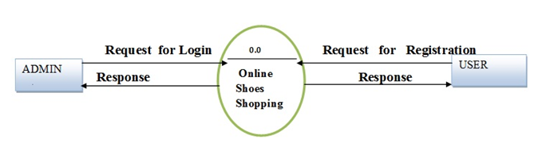
* 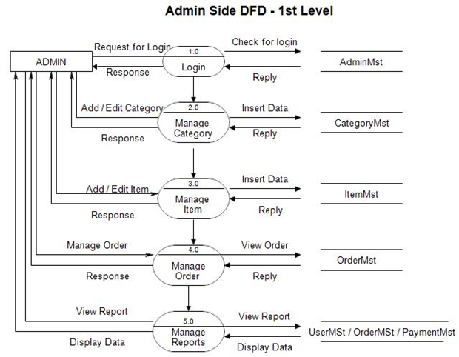

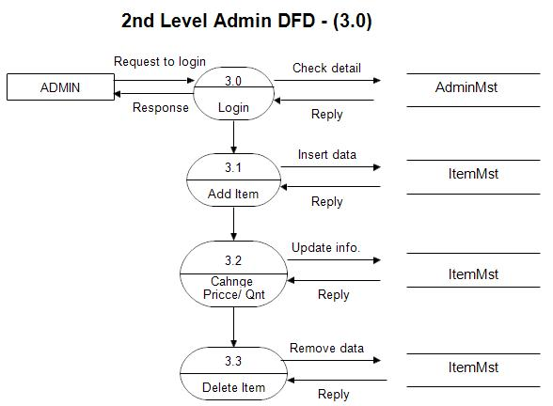

**Entity Relationship Diagram (ERD)**

[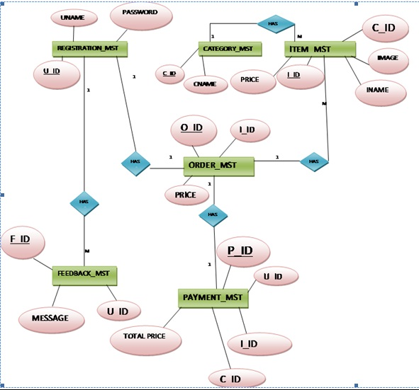](https://www.youtube.com/coderbaba)

**System Design**

* **DATABASE DESIGN: -**

**Forget Password: -**

|  |  |  |  |
| --- | --- | --- | --- |
| **Column Name** | **Data Type** | **Constraint** | **Description** |
| Id | nvarchar(500) | **-** | Id |
| Uid | int | **-** | UId |
| RequstDateTime | datetime | **-** | RequstDateTime |

**Brand: -**

|  |  |  |  |
| --- | --- | --- | --- |
| **Column Name** | **Data Type** | **Constraint** | **Description** |
| BrandId | int | **-** | BrandId |
| Name | nvarchar(30) | **-** | Name |

**Cart: -**

|  |  |  |  |
| --- | --- | --- | --- |
| **Column Name** | **Data Type** | **Constraint** | **Description** |
| CartId | int | **-** | CartId |
| CartName | nvarchar(MAX) | **-** | CartName |

**Category: -**

|  |  |  |  |
| --- | --- | --- | --- |
| **Column Name** | **Data Type** | **Constraint** | **Description** |
| CatId | int | **-** | CatId |
| CatName | nvarchar(MAX) | **-** | CatName |

**Gender: -**

|  |  |  |  |
| --- | --- | --- | --- |
| **Column Name** | **Data Type** | **Constraint** | **Description** |
| GenderId | int | - | GenderId |
| GenderName | Nvarchar(MAX) | - | GenderName |

Ordered Products: -

|  |  |  |  |
| --- | --- | --- | --- |
| **Column Name** | **Data Type** | **Constraint** | **Description** |
| Id | int | - | Id |
| OrderCode | nvarchar(15) | - | OrderCode |
| Prod_ID | int | - | Prod_ID |
| Qty | int | - | Qty |
| Price | decimal(18,2) | - | Price |
| TotalAmount | decimal(18,2) | - | TotalAmount |

**Order Products: -**

|  |  |  |  |
| --- | --- | --- | --- |
| **Column Name** | **Data Type** | **Constraint** | **Description** |
| OrderProID | int | - | OrderProID |
| OrderId | nvarchar(50) | - | OrderId |
| UserID | int | - | UserID |
| PID | int | - | PID |
| Products | Nvarchar(MAX) | - | Products |
| Quantity | int | - | Quantity |
| OrderDate | datetime | - | OrderDate |
| Status | nvarchar(100) |  | Status |

**Table Orders: -**

|  |  |  |  |
| --- | --- | --- | --- |
| **Column Name** | **Data Type** | **Constraint** | **Description** |
| UserId | int | - | UserId |
| Email | int | - | Email |
| CartAmount | nvarchar(MAX) | - | CartAmount |
| CartDiscount | money | - | CartDiscount |
| TotalPaid | money | - | TotalPaid |
| PaymentType | money | - | PaymentType |
| PaymentStatus | nvarchar(50) | - | PaymentStatus |
| DateofPurchase | datetime | - | DateofPurchase |
| Name | nvarchar(200) | - | Name |
| Address | nvarchar(MAX) | - | Address |
| MobileNumber | nvarchar(50) | - | MobileNumber |
| OrderStatus | nvarchar(50) | - | OrderStatus |
| OrderNumber | nvarchar(50) |  | OrderNumber |

**Product Images: -**

|  |  |  |  |
| --- | --- | --- | --- |
| **Column Name** | **Data Type** | **Constraint** | **Description** |
| PIMGID | Int | - | PIMGID |
| PiD | Int | - | PiD |
| Name | nvarchar(MAX) | - | Name |
| Extension | nvarchar(500) | - | Extension |

**Products: -**

|  |  |  |  |
| --- | --- | --- | --- |
| **Column Name** | **Data Type** | **Constraint** | **Description** |
| Pid | int | - | Pid |
| PName | nvarchar(MAX) | - | PName |
| PPrice | money | - | PPrice |
| PSellPrice | money | - | PSellPrice |
| PBrandId | int | - | PBrandId |
| PCatagoryId | int | - | PCatagoryId |
| PSubCatId | int | - | PSubCatId |
| PGender | int | - | PGender |
| PDescription | nvarchar(MAX) | - | PDescription |
| PProductDetails | nvarchar(MAX) | - | PProductDetails |
| PMaterialCare | nvarchar(MAX) | - | PMaterialCare |
| FreeDalivery | int | - | FreeDalivery |
| [30dayRet] | int | - | [30dayRet] |
| Cod | int | - | Cod |



**ProductSizeQuantity: -**

|  |  |  |  |
| --- | --- | --- | --- |
| **Column Name** | **Data Type** | **Constraint** | **Description** |
| ProsizeQuantityId |  | - |  |
| PId |  | - |  |
| SizeId |  | - |  |
| Quantity |  | - |  |

**Purchase: -**

|  |  |  |  |
| --- | --- | --- | --- |
| **Column Name** | **Data Type** | **Constraint** | **Description** |
| purchaseID | int | - | purchaseID |
| UserID | int | - | UserID |
| PIDSizeID | nvarchar(Max) | - | PIDSizeID |
| CartAmount | money | - | CartAmount |
| CartDiscount | money | - | CartDiscount |
| TotalPayed | money | - | TotalPayed |
| PaymentType | nvarchar(50) | - | PaymentType |
| PaymentStatus | nvarchar(50) | - | PaymentStatus |
| DateOfPurchase | datetime | - | DateOfPurchase |
| Name | nvarchar(200) | - | Name |
| Address | nvarchar(Max) | - | Address |
| PinCode | nvarchar(10) | - | PinCode |
| MobileNumber | nvarchar(50) | - | MobileNumber |

**Size: -**

|  |  |  |  |
| --- | --- | --- | --- |
| **Column Name** | **Data Type** | **Constraint** | **Description** |
| SizeID | int | - | SizeID |
| SizeName | nvarchar(500) | - | SizeName |
| BrandID | int | - | BrandID |
| CategoryID | int | - | CategoryID |
| SubCategoryID | int | - | SubCategoryID |
| GenderID | int | - | GenderID |

**Subcategory: -**

|  |  |  |  |
| --- | --- | --- | --- |
| **Column Name** | **Data Type** | **Constraint** | **Description** |
| SubCatID | int | - | SubCatID |
| SubCatName | nvaarchar(MAX) | - | SubCatName |
| MainCatID | int | - | MainCatID |

**Users: -**

|  |  |  |  |
| --- | --- | --- | --- |
| **Column Name** | **Data Type** | **Constraint** | **Description** |
| Uid | int | - | Uid |
| Username | nvarchar(100) | - | Username |
| Password | nvarchar(100) | - | Password |
| Email | nvarchar(100) | - | Email |
| Name | nvarchar(100) | - | Name |
| UserType | nvarchar(50) | - | UserType |

“**Forms Design**”

**Sign in: -**

* 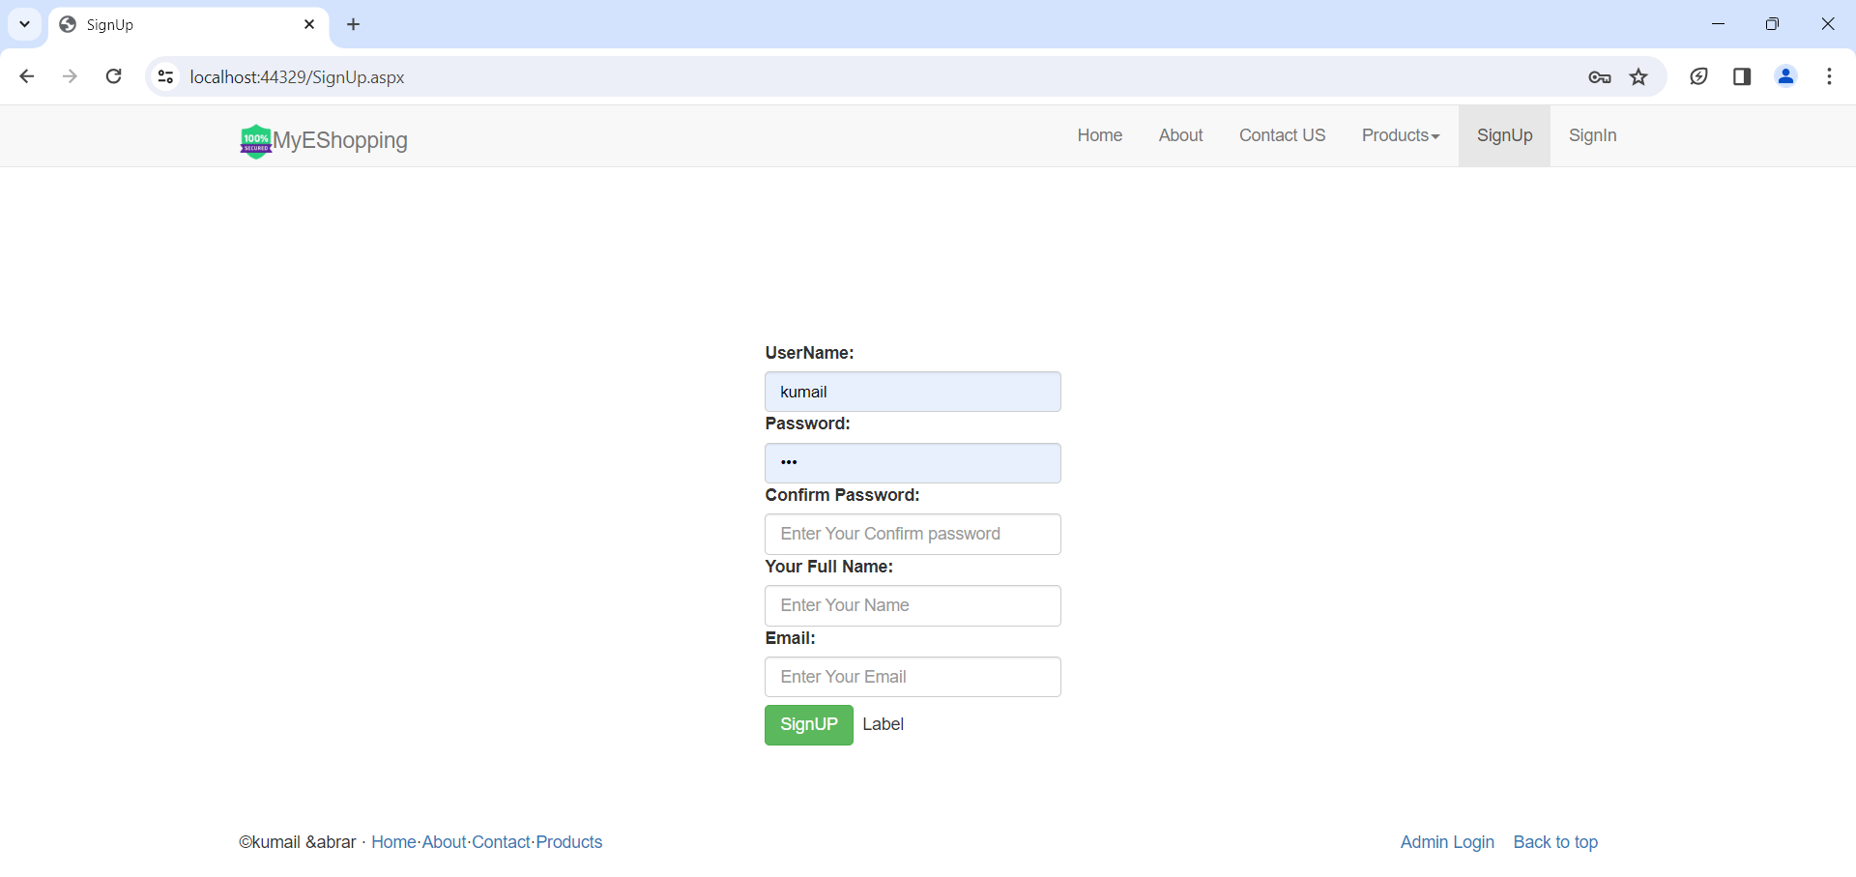

**Login: -**

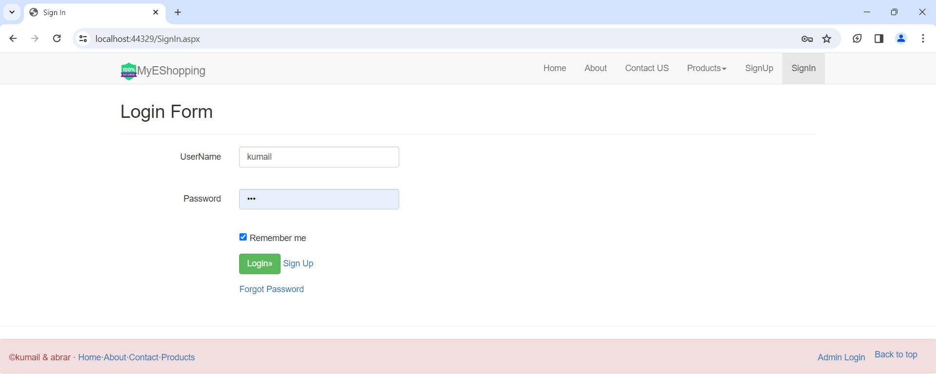

**Home:-**

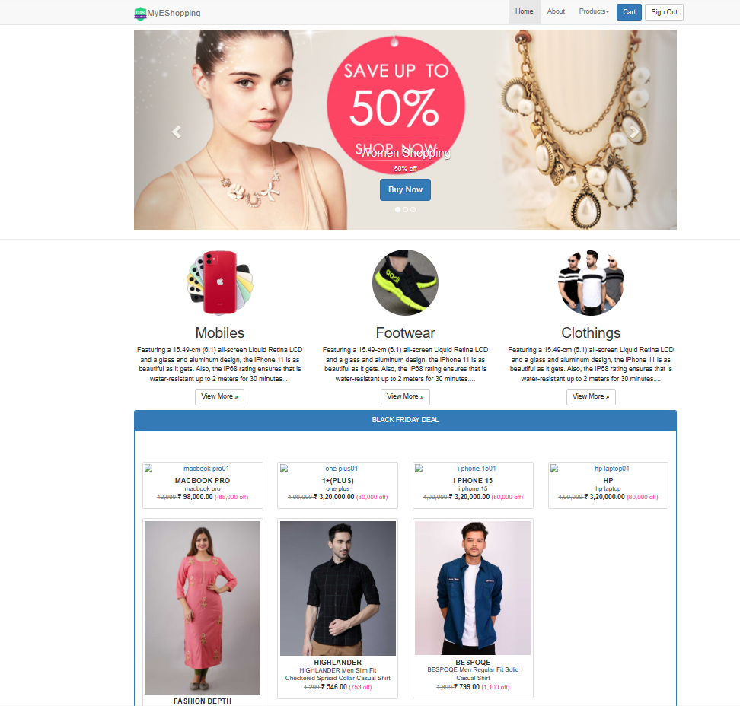

**Add Product:-**

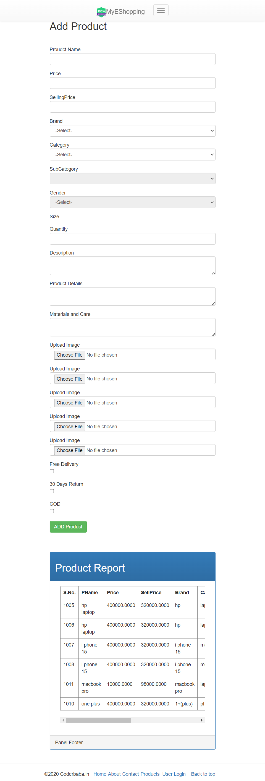

**Cart:-**

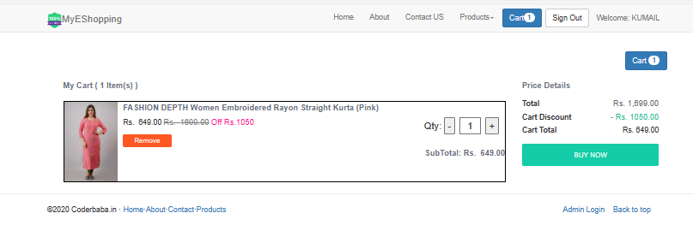

**All products:-**

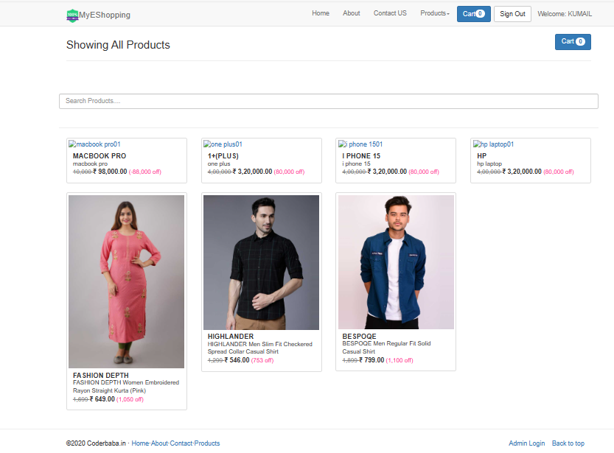

**Add Category:-**

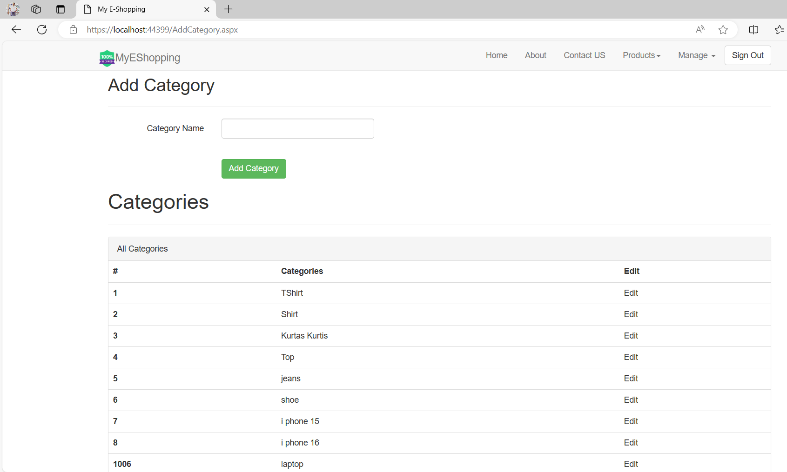

**Add Brand:-**

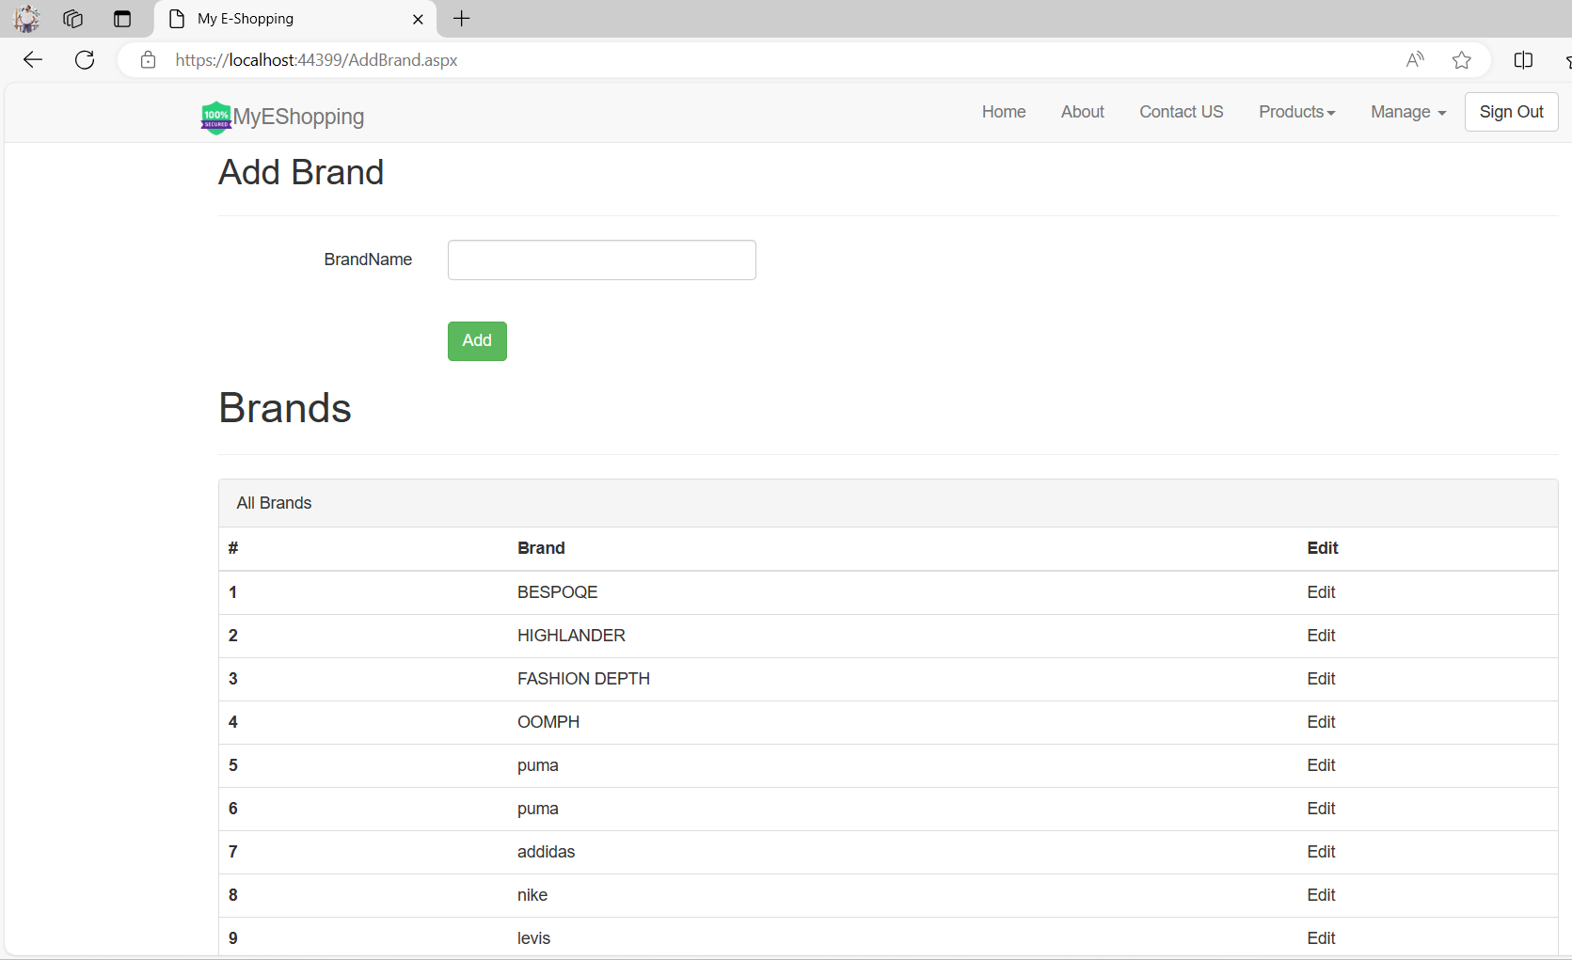

**Add Sub Category:-**

* 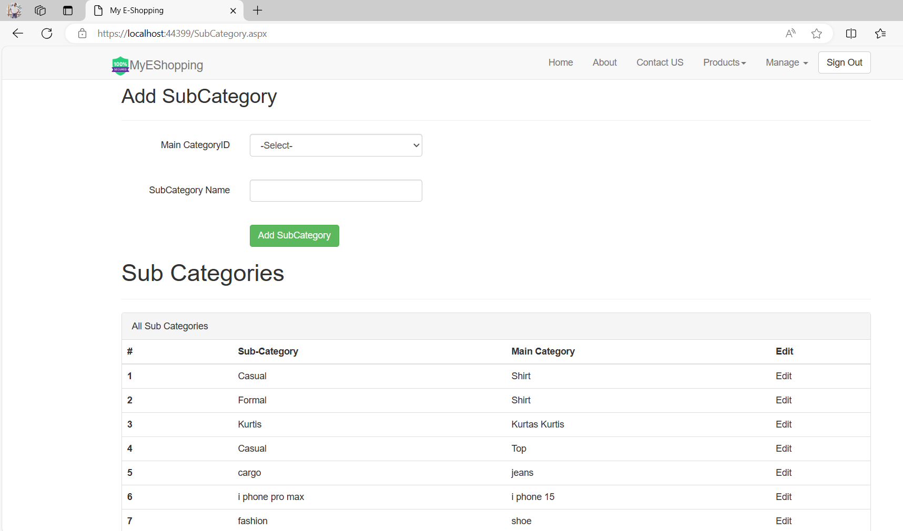

**Add Gender:-**

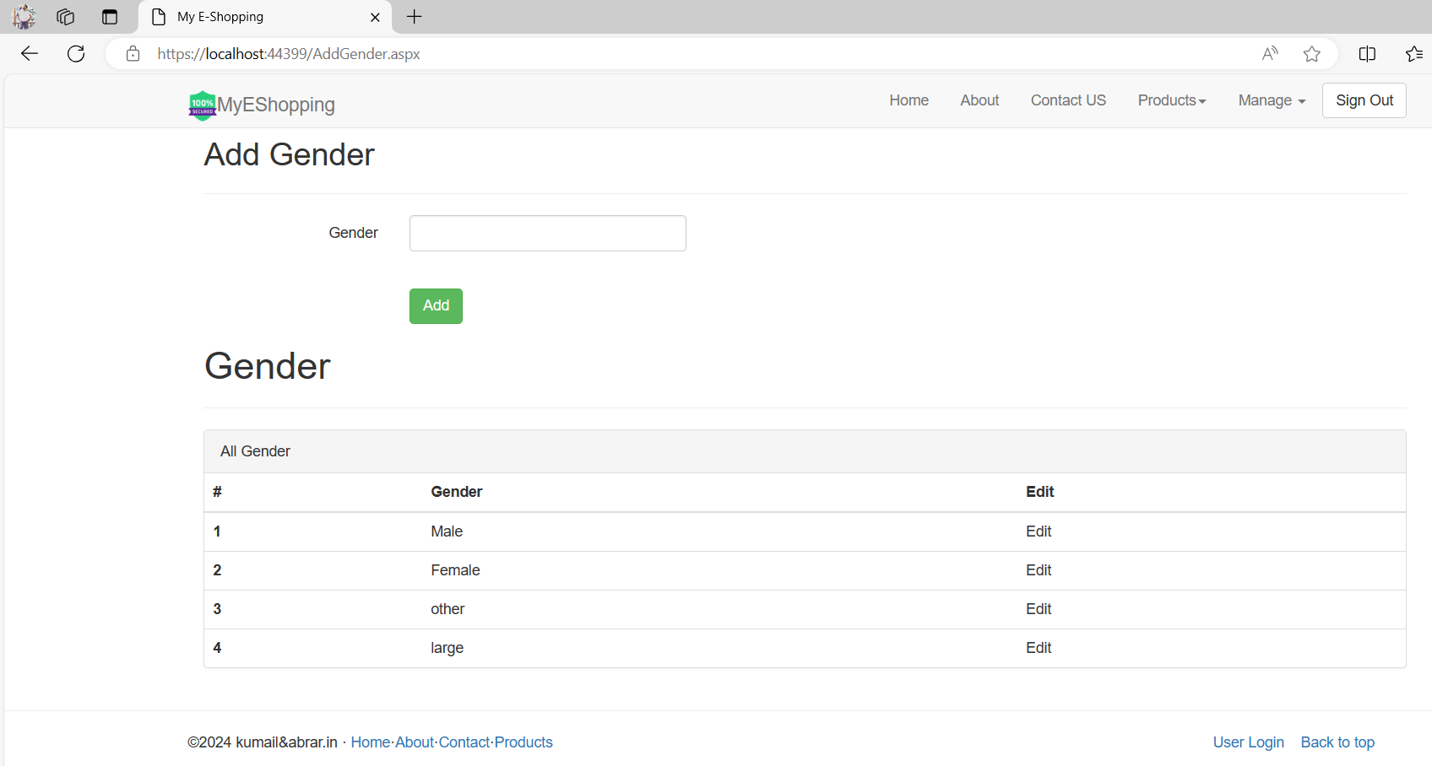

**Add Size:-**

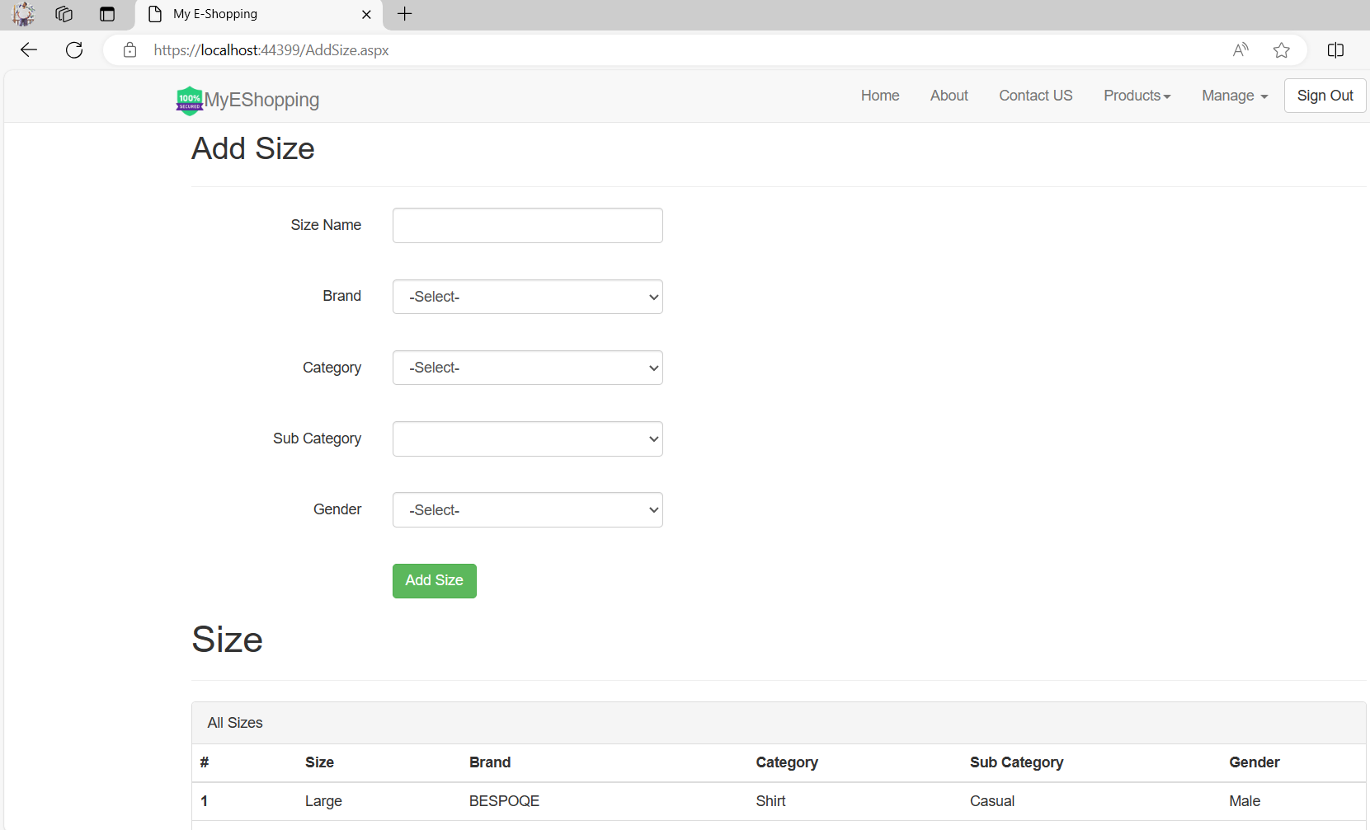

**Crystil reports:-**

**Cart:-**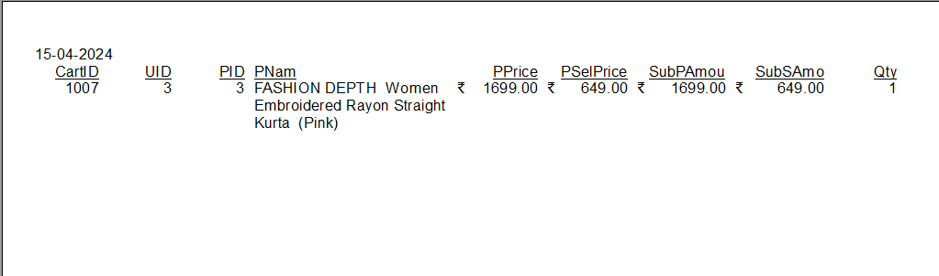

**Products:-**

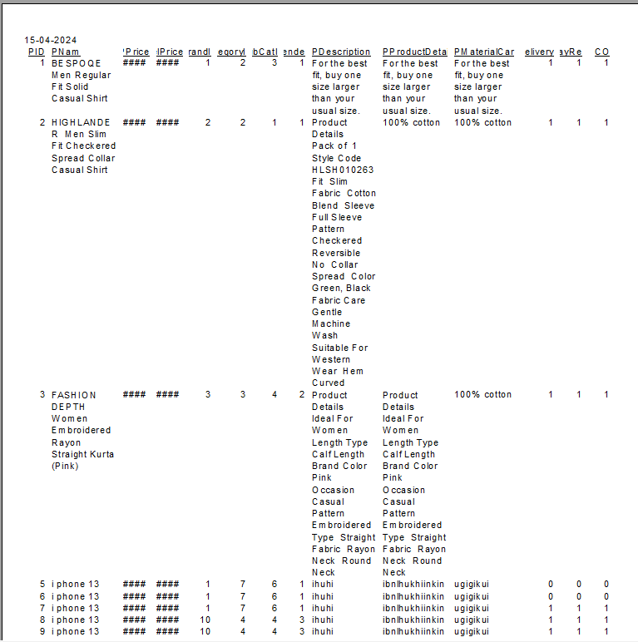

**Orders: -**

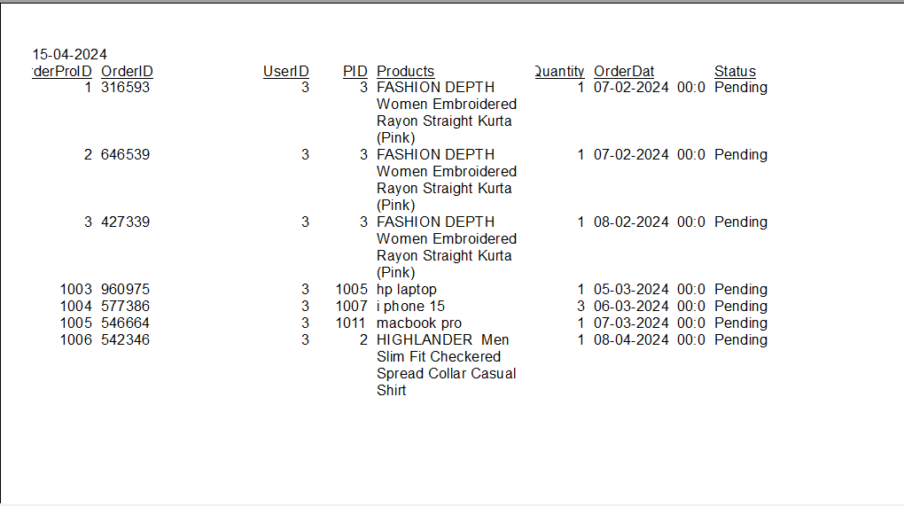

**Source Code: -**

**Login: -**

using System;

using System.Collections.Generic;

using System.Linq;

using System.Web;

using System.Web.UI;

using System.Web.UI.WebControls;

using System.Data.SqlClient;

using System.Configuration;

using System.Data;

public partial class SignIn : System.Web.UI.Page

{

protected void Page_Load(object sender, EventArgs e)

{

if (!IsPostBack)

{

if (Request.Cookies["UNAME"] != null && Request.Cookies["UPWD"] != null )

{

txtUsername.Text= Request.Cookies["UNAME"].Value ;

txtPass .Text = Request.Cookies["UPWD"].Value;

CheckBox1.Checked = true;

}

}

}

protected void btnLogin_Click(object sender, EventArgs e)

{

using (SqlConnection con = new SqlConnection(ConfigurationManager.ConnectionStrings["MyShoppingDB"].ConnectionString))

{

con.Open();

SqlCommand cmd = new SqlCommand("Select * from tblUsers where Username=@username and Password=@pwd", con);

cmd.Parameters.AddWithValue("@username",txtUsername .Text );

cmd.Parameters.AddWithValue("@pwd", txtPass .Text);

SqlDataAdapter sda = new SqlDataAdapter(cmd);

DataTable dt = new DataTable();

sda.Fill(dt);

if (dt.Rows.Count != 0)

{

Session["USERID"] = dt.Rows[0]["Uid"].ToString();

Session["USEREMAIL"] = dt.Rows[0]["Email"].ToString();

Response.Cookies["UNAME"].Expires = DateTime.Now.AddDays(-1);

Response.Cookies["UPWD"].Expires = DateTime.Now.AddDays(-1);

if (CheckBox1 .Checked)

{

Response.Cookies["UNAME"].Value = txtUsername.Text;

Response.Cookies["UPWD"].Value = txtPass .Text;

Response.Cookies["UNAME"].Expires = DateTime.Now.AddDays(10);

Response.Cookies["UPWD"].Expires = DateTime.Now.AddDays(10);

}

else

{

Response.Cookies["UNAME"].Expires = DateTime.Now.AddDays(-1);

Response.Cookies["UPWD"].Expires = DateTime.Now.AddDays(-1);

}

string Utype;

Utype = dt.Rows[0][5].ToString().Trim();

if(Utype =="User")

{

Session["Username"] = txtUsername.Text;

Session["USEREMAIL"] = dt.Rows[0]["Email"].ToString();

Session["getFullName"] = dt.Rows[0]["name"].ToString();

//Session["Mobile"] = dt.Rows[0]["Mobile"].ToString();

Session["LoginType"] = "User";

if (Request.QueryString["rurl"] != null)

{

if (Request.QueryString["rurl"] == "cart")

{

Response.Redirect("Cart.aspx");

}

if (Request.QueryString["rurl"] == "PID")

{

string myPID = Session["ReturnPID"].ToString();

Response.Redirect("ProductView.aspx?PID=" + myPID + "");

}

}

else

{

Response.Redirect("UserHome.aspx?UserLogin=YES");

}

}

if (Utype == "Admin")

{

Session["Username"] = txtUsername.Text;

Session["LoginType"] = "Admin";

Response.Redirect("~/AdminHome.aspx");

}

}

else

{

lblError.Text = "Invalid Username and password";

}

//Response.Write("<script> alert('Login Successfully done'); </script>");

clr();

con.Close();

//lblMsg.Text = "Registration Successfully done";

//lblMsg.ForeColor = System.Drawing.Color.Green;

}

}

private void clr()

{

txtPass.Text = string.Empty;

txtUsername.Text = string.Empty;

txtUsername.Focus();

}

}

**Signup: -**

using System;

using System.Collections.Generic;

using System.Linq;

using System.Web;

using System.Web.UI;

using System.Web.UI.WebControls;

using System.Data;

using System.Data.SqlClient;

using System.Configuration;

public partial class SignUp : System.Web.UI.Page

{

protected void Page_Load(object sender, EventArgs e)

{

}

protected void txtsignup_Click(object sender, EventArgs e)

{

if(isformvalid())

{

using (SqlConnection con = new SqlConnection(ConfigurationManager .ConnectionStrings ["MyShoppingDB"].ConnectionString ))

{

con.Open();

SqlCommand cmd = new SqlCommand("Insert into tblUsers(Username,Password,Email,Name,Usertype) Values('" + txtUname.Text + "','" + txtPass.Text + "','" + txtEmail.Text + "','" + txtName.Text + "','User')", con);

cmd.ExecuteNonQuery();

Response.Write("<script> alert('Registration Successfully done'); </script>");

clr();

con.Close();

lblMsg.Text = "Registration Successfully done";

lblMsg.ForeColor = System.Drawing.Color.Green;

}

Response.Redirect("~/SignIn.aspx");

}

else

{

Response.Write("<script> alert('Registration failed'); </script>");

lblMsg.ForeColor = System.Drawing.Color.Red;

}

}

private bool isformvalid()

{

if (txtUname.Text == "")

{

Response.Write("<script> alert('username not valid'); </script>");

txtUname.Focus();

return false;

}

else if(txtPass.Text =="")

{

Response.Write("<script> alert('Password not valid'); </script>");

txtPass.Focus();

return false;

}

else if (txtPass.Text != txtCPass .Text )

{

Response.Write("<script> alert('confirm Password not valid'); </script>");

txtCPass.Focus();

return false;

}

else if (txtEmail .Text == "")

{

Response.Write("<script> alert('Email not valid'); </script>");

txtEmail.Focus();

return false;

}

else if (txtName .Text == "")

{

Response.Write("<script> alert('Name not valid'); </script>");

txtName.Focus();

return false;

}

return true;

}

private void clr()

{

txtName.Text = string.Empty;

txtPass.Text = string.Empty;

txtUname. Text = string.Empty;

txtEmail. Text = string.Empty;

txtCPass.Text = string.Empty;

}

}

**Admin Home: -**

using System;

using System.Collections.Generic;

using System.Linq;

using System.Web;

using System.Web.UI;

using System.Web.UI.WebControls;

public partial class AdminHome : System.Web.UI.Page

{

protected void Page_Load(object sender, EventArgs e)

{

}

}

**User home: -**

using System;

using System.Collections.Generic;

using System.Linq;

using System.Web;

using System.Web.UI;

using System.Web.UI.WebControls;

using System.Data;

using System.Data.SqlClient;

using System.Configuration;

using System.Globalization;

using System.Threading;

public partial class UserHome : System.Web.UI.Page

{

public static String CS = ConfigurationManager.ConnectionStrings["MyShoppingDB"].ConnectionString;

protected void Page_Load(object sender, EventArgs e)

{

BindCartNumber22();

if (Session["Username"]!=null)

{

btnlogout.Visible = true;

btnLogin.Visible = false;

lblSuccess.Text = "Login Success, Welcome <b>" + Session["Username"].ToString()+"</b>";

Button1.Text ="Welcome: " + Session["Username"].ToString().ToUpper() ;

}

else

{

btnlogout.Visible = false;

btnLogin.Visible = true;

Response.Redirect("SignIn.aspx");

}

}

protected void btnlogout_Click(object sender, EventArgs e)

{

//Session.Abandon();

Session["Username"] = null;

Response.Redirect("~/Default.aspx");

}

protected void btnLogin_Click(object sender, EventArgs e)

{

Response.Redirect("~/SignIn.aspx");

}

public void BindCartNumber()

{

if (Request.Cookies["CartPID"] != null)

{

string CookiePID = Request.Cookies["CartPID"].Value.Split('=')[1];

string[] ProductArray = CookiePID.Split(',');

int ProductCount = ProductArray.Length;

pCount.InnerText = ProductCount.ToString();

}

else

{

pCount.InnerText = 0.ToString();

}

}

public void BindCartNumber22()

{

if (Session["USERID"] != null)

{

string UserIDD = Session["USERID"].ToString();

DataTable dt = new DataTable();

using (SqlConnection con = new SqlConnection(CS))

{

SqlCommand cmd = new SqlCommand("SP_BindCartNumberz", con)

{

CommandType = CommandType.StoredProcedure

};

cmd.Parameters.AddWithValue("@UserID", UserIDD);

using (SqlDataAdapter sda = new SqlDataAdapter(cmd))

{

sda.Fill(dt);

if (dt.Rows.Count > 0)

{

string CartQuantity = dt.Compute("Sum(Qty)", "").ToString();

pCount.InnerText = CartQuantity;

}

else

{

//_ = CartBadge.InnerText == 0.ToString();

pCount.InnerText ="0";

}

using System;

using System.Collections.Generic;

using System.Linq;

using System.Web;

using System.Web.UI;

using System.Web.UI.WebControls;

using System.Data;

using System.Data.SqlClient;

using System.Configuration;

using System.IO;

public partial class AddProduct : System.Web.UI.Page

{

public static String CS = ConfigurationManager.ConnectionStrings["MyShoppingDB"].ConnectionString;

protected void Page_Load(object sender, EventArgs e)

{

if(!IsPostBack)

{

//when page first time run then this code will execute

BindBrand();

BindCategory();

BindGender();

ddlSubCategory.Enabled = false;

ddlGender .Enabled = false;

BindGridview1();

}

}

private void BindGender()

{

using (SqlConnection con = new SqlConnection(CS))

{

con.Open();

SqlCommand cmd = new SqlCommand("Select * from tblGender with(nolock)", con);

SqlDataAdapter sda = new SqlDataAdapter(cmd);

DataTable dt = new DataTable();

sda.Fill(dt);

if (dt.Rows.Count != 0)

{

ddlGender.DataSource = dt;

ddlGender.DataTextField = "GenderName";

ddlGender.DataValueField = "GenderID";

ddlGender.DataBind();

ddlGender.Items.Insert(0, new ListItem("-Select-", "0"));

}

}

}

private void BindCategory()

{

using (SqlConnection con = new SqlConnection(CS))

{

con.Open();

SqlCommand cmd = new SqlCommand("Select * from tblCategory", con);

SqlDataAdapter sda = new SqlDataAdapter(cmd);

DataTable dt = new DataTable();

sda.Fill(dt);

if (dt.Rows.Count != 0)

{

ddlCategory.DataSource = dt;

ddlCategory.DataTextField = "CatName";

ddlCategory.DataValueField = "CatID";

ddlCategory.DataBind();

ddlCategory.Items.Insert(0, new ListItem("-Select-", "0"));

}

}

}

private void BindBrand()

{

using (SqlConnection con = new SqlConnection(CS))

{

con.Open();

SqlCommand cmd = new SqlCommand("Select * from tblBrands", con);

SqlDataAdapter sda = new SqlDataAdapter(cmd);

DataTable dt = new DataTable();

sda.Fill(dt);

if (dt.Rows.Count != 0)

{

ddlBrand.DataSource = dt;

ddlBrand.DataTextField = "Name";

ddlBrand.DataValueField = "BrandID";

ddlBrand.DataBind();

ddlBrand.Items.Insert(0, new ListItem("-Select-", "0"));

}

}

}

protected void btnAdd_Click(object sender, EventArgs e)

{

using (SqlConnection con = new SqlConnection(CS))

{

SqlCommand cmd = new SqlCommand("sp_InsertProduct", con);

cmd.CommandType = CommandType.StoredProcedure;

cmd.Parameters.AddWithValue("@PName",txtProductName.Text );

cmd.Parameters.AddWithValue("@PPrice",txtPrice.Text );

cmd.Parameters.AddWithValue("@PSelPrice", txtsellPrice.Text);

cmd.Parameters.AddWithValue("@PBrandID", ddlBrand.SelectedItem .Value );

cmd.Parameters.AddWithValue("@PCategoryID", ddlCategory.SelectedItem.Value);

cmd.Parameters.AddWithValue("@PSubCatID", ddlSubCategory.SelectedItem.Value);

cmd.Parameters.AddWithValue("@PGender", ddlGender.SelectedItem.Value);

cmd.Parameters.AddWithValue("@PDescription", txtDescription.Text );

cmd.Parameters.AddWithValue("@PProductDetails", txtPDetail.Text);

cmd.Parameters.AddWithValue("@PMaterialCare", txtMatCare.Text);

if (chFD .Checked ==true )

{

cmd.Parameters.AddWithValue("@FreeDelivery", 1.ToString ());

}

else

{

cmd.Parameters.AddWithValue("@FreeDelivery", 0.ToString());

}

if (ch30Ret .Checked == true)

{

cmd.Parameters.AddWithValue("@30DayRet", 1.ToString());

}

else

{

cmd.Parameters.AddWithValue("@30DayRet", 0.ToString());

}

if (cbCOD.Checked == true)

{

cmd.Parameters.AddWithValue("@COD", 1.ToString());

}

else

{

cmd.Parameters.AddWithValue("@COD", 0.ToString());

}

if (con.State == ConnectionState.Closed) { con.Open(); }

Int64 PID = Convert.ToInt64(cmd.ExecuteScalar ());

//Insert size quantity

for(int i=0; i<cblSize .Items .Count;i++)

{

if(cblSize .Items [i].Selected ==true )

{

Int64 SizeID = Convert.ToInt64(cblSize.Items[i].Value);

int Quantity = Convert.ToInt32(txtQuantity.Text);

// SqlCommand cmd2 = new SqlCommand("insert into tblProductSizeQuantity(PID,SizeID,Quantity) values('" + PID + "','" + SizeID + "','" + Quantity + "')", con);

SqlCommand cmd2 = new SqlCommand("insert into tblProductSizeQuantity(PID,SizeID,Quantity) values(@PID,@SizeID,@Quantity)", con);

cmd2.Parameters.AddWithValue("@PID", Convert.ToInt32(PID));

cmd2.Parameters.AddWithValue("@SizeID", Convert.ToInt32(SizeID));

cmd2.Parameters.AddWithValue("@Quantity", Convert.ToInt32(Quantity));

cmd2.ExecuteNonQuery();

}

}

//Insert and upload images

if(fuImg01.HasFile )

{

string SavePath = Server.MapPath("~/Images/ProductImages/") + PID ;

if(!Directory.Exists (SavePath ))

{

Directory.CreateDirectory(SavePath);

}

string Extention = Path.GetExtension(fuImg01.PostedFile.FileName);

fuImg01.SaveAs(SavePath + "\\" + txtProductName.Text.ToString().Trim() + "01" + Extention);

//SqlCommand cmd3 = new SqlCommand("insert into tblProductImages values('" + PID + "','" + txtProductName.Text.ToString ().Trim () + "01" + "','" + Extention + "')", con);

SqlCommand cmd3 = new SqlCommand("insert into tblProductImages(PID,Name,Extention) values(@PID,@Name,@Extention)", con);

cmd3.Parameters.AddWithValue("@PID",Convert.ToInt32(PID));

cmd3.Parameters.AddWithValue("@Name", txtProductName.Text.ToString().Trim() + "01");

cmd3.Parameters.AddWithValue("@Extention", Extention);

cmd3.ExecuteNonQuery();

}

//2nd fileupload

if (fuImg02.HasFile)

{

string SavePath = Server.MapPath("~/Images/ProductImages/") + PID;

if (!Directory.Exists(SavePath))

{

Directory.CreateDirectory(SavePath);

}

string Extention = Path.GetExtension(fuImg02.PostedFile.FileName);

fuImg02.SaveAs(SavePath + "\\" + txtProductName.Text.ToString().Trim() + "02" + Extention);

//SqlCommand cmd4 = new SqlCommand("insert into tblProductImages values('" + PID + "','" + txtProductName.Text.ToString().Trim() + "02" + "','" + Extention + "')", con);

SqlCommand cmd4 = new SqlCommand("insert into tblProductImages(PID,Name,Extention) values(@PID,@Name,@Extention)", con);

cmd4.Parameters.AddWithValue("@PID", Convert.ToInt32(PID));

cmd4.Parameters.AddWithValue("@Name", txtProductName.Text.ToString().Trim() + "02");

cmd4.Parameters.AddWithValue("@Extention", Extention);

cmd4.ExecuteNonQuery();

}

//3rd file upload

if (fuImg03.HasFile)

{

string SavePath = Server.MapPath("~/Images/ProductImages/") + PID;

if (!Directory.Exists(SavePath))

{

Directory.CreateDirectory(SavePath);

}

string Extention = Path.GetExtension(fuImg03.PostedFile.FileName);

fuImg03.SaveAs(SavePath + "\\" + txtProductName.Text.ToString().Trim() + "03" + Extention);

//SqlCommand cmd5 = new SqlCommand("insert into tblProductImages values('" + PID + "','" + txtProductName.Text.ToString().Trim() + "03" + "','" + Extention + "')", con);

SqlCommand cmd5 = new SqlCommand("insert into tblProductImages(PID,Name,Extention) values(@PID,@Name,@Extention)", con);

cmd5.Parameters.AddWithValue("@PID", Convert.ToInt32(PID));

cmd5.Parameters.AddWithValue("@Name", txtProductName.Text.ToString().Trim() + "03");

cmd5.Parameters.AddWithValue("@Extention", Extention);

cmd5.ExecuteNonQuery();

}

//4th file upload control

if (fuImg04.HasFile)

{

string SavePath = Server.MapPath("~/Images/ProductImages/") + PID;

if (!Directory.Exists(SavePath))

{

Directory.CreateDirectory(SavePath);

}

string Extention = Path.GetExtension(fuImg04.PostedFile.FileName);

fuImg04.SaveAs(SavePath + "\\" + txtProductName.Text.ToString().Trim() + "04" + Extention);

//SqlCommand cmd6 = new SqlCommand("insert into tblProductImages values('" + PID + "','" + txtProductName.Text.ToString().Trim() + "04" + "','" + Extention + "')", con);

SqlCommand cmd6 = new SqlCommand("insert into tblProductImages(PID,Name,Extention) values(@PID,@Name,@Extention)", con);

cmd6.Parameters.AddWithValue("@PID", Convert.ToInt32(PID));

cmd6.Parameters.AddWithValue("@Name", txtProductName.Text.ToString().Trim() + "04");

cmd6.Parameters.AddWithValue("@Extention", Extention);

cmd6.ExecuteNonQuery();

}

//5th file upload

if (fuImg05.HasFile)

{

string SavePath = Server.MapPath("~/Images/ProductImages/") + PID;

if (!Directory.Exists(SavePath))

{

Directory.CreateDirectory(SavePath);

}

string Extention = Path.GetExtension(fuImg05.PostedFile.FileName);

fuImg05.SaveAs(SavePath + "\\" + txtProductName.Text.ToString().Trim() + "05" + Extention);

//SqlCommand cmd7 = new SqlCommand("insert into tblProductImages values('" + PID + "','" + txtProductName.Text.ToString().Trim() + "05" + "','" + Extention + "')", con);

SqlCommand cmd7 = new SqlCommand("insert into tblProductImages(PID,Name,Extention) values(@PID,@Name,@Extention)", con);

cmd7.Parameters.AddWithValue("@PID", Convert.ToInt32(PID));

cmd7.Parameters.AddWithValue("@Name", txtProductName.Text.ToString().Trim() + "05");

cmd7.Parameters.AddWithValue("@Extention", Extention);

cmd7.ExecuteNonQuery();

BindGridview1();

Response.Redirect("AddProduct.aspx");

}

}

}

protected void ddlCategory_SelectedIndexChanged(object sender, EventArgs e)

{

ddlSubCategory.Enabled = true;

int MainCategoryID = Convert.ToInt32(ddlCategory.SelectedItem.Value);

using (SqlConnection con = new SqlConnection(CS))

{

con.Open();

SqlCommand cmd = new SqlCommand("Select * from tblSubCategory where MainCatID='" + ddlCategory.SelectedItem.Value + "'", con);

SqlDataAdapter sda = new SqlDataAdapter(cmd);

DataTable dt = new DataTable();

sda.Fill(dt);

if (dt.Rows.Count != 0)

{

ddlSubCategory.DataSource = dt;

ddlSubCategory.DataTextField = "SubCatName";

ddlSubCategory.DataValueField = "SubCatID";

ddlSubCategory.DataBind();

ddlSubCategory.Items.Insert(0, new ListItem("-Select-", "0"));

}

}

}

protected void ddlGender_SelectedIndexChanged(object sender, EventArgs e)

{

using (SqlConnection con = new SqlConnection(CS))

{

if (con.State == ConnectionState.Closed) { con.Open(); }

string qr = "Select * from tblSizes where BrandID=@BrandID AND CategoryID=@CategoryID AND SubCategoryID=@SubCategoryID AND GenderID=@GenderID ";

// qr = "Select * from tblSizes where BrandID='" + ddlBrand.SelectedValue + "' and CategoryID='" + ddlCategory.SelectedValue + "' and SubCategoryID='" + ddlSubCategory.SelectedValue + "' and GenderID='" + ddlGender.SelectedValue + "'";

SqlCommand cmd = new SqlCommand(qr, con);

cmd.Parameters.AddWithValue("@BrandID",ddlBrand.SelectedValue);

cmd.Parameters.AddWithValue("@CategoryID",ddlCategory.SelectedValue);

cmd.Parameters.AddWithValue("@SubCategoryID",ddlSubCategory.SelectedValue);

cmd.Parameters.AddWithValue("@GenderID", ddlGender.SelectedValue);

SqlDataAdapter sda = new SqlDataAdapter(cmd);

DataTable dt = new DataTable();

sda.Fill(dt);

con.Close();

if (dt.Rows.Count != 0)

{

cblSize.DataSource = dt;

cblSize.DataTextField = "SizeName";

cblSize.DataValueField = "SizeID";

cblSize.DataBind();

}

}

}

protected void ddlSubCategory_SelectedIndexChanged(object sender, EventArgs e)

{

if(ddlSubCategory .SelectedIndex !=0)

{

ddlGender.Enabled = true;

}

else

{

ddlGender.Enabled = false ;

}

}

private void BindGridview1()

{

SqlConnection con = new SqlConnection(CS);

SqlCommand cmd = new SqlCommand(" select distinct t1.PID,t1.PName,t1.PPrice,t1.PSelPrice,t2.Name as Brand,t3.CatName,t4.SubCatName, t5.GenderName as gender,t6.SizeName,t8.Quantity from tblProducts as t1 inner join tblBrands as t2 on t2.BrandID=t1.PBrandID inner join tblCategory as t3 on t3.CatID=t1.PCategoryID inner join tblSubCategory as t4 on t4.SubCatID=t1.PSubCatID inner join tblGender as t5 on t5.GenderID =t1.PGender inner join tblSizes as t6 on t6.SubCategoryID=t1.PSubCatID inner join tblProductSizeQuantity as t8 on t8.PID=t1.PID order by t1.PName",con);

SqlDataAdapter da = new SqlDataAdapter(cmd);

DataTable dt = new DataTable();

da.Fill(dt);

if (dt.Rows.Count > 0)

{

GridView1.DataSource = dt;

GridView1.DataBind();

}

else

{

GridView1.DataSource = null;

GridView1.DataBind();

}

}

}z

}

}

}

}

**product: -**

using System;

using System.Collections.Generic;

using System.Linq;

using System.Web;

using System.Web.UI;

using System.Web.UI.WebControls;

using System.Data;

using System.Data.SqlClient;

using System.Configuration;

using System.Globalization;

using System.Threading;

public partial class Products : System.Web.UI.Page

{

public static String CS = ConfigurationManager.ConnectionStrings["MyShoppingDB"].ConnectionString;

protected void Page_Load(object sender, EventArgs e)

{

if (Session["Username"] != null)

{

if (!IsPostBack)

{

if(Request.QueryString["BuyNow"]=="YES")

{

}

BindProductRepeater();

BindCartNumber();

}

}

else

{

if (Request.QueryString["BuyNow"] == "YES")

{

Response.Redirect("SignIn.aspx");

}

else

{

Response.Redirect("~/Default.aspx");

}

}

}

protected override void InitializeCulture()

{

CultureInfo ci = new CultureInfo("en-IN");

ci.NumberFormat.CurrencySymbol = "₹";

Thread.CurrentThread.CurrentCulture = ci;

base.InitializeCulture();

}

private void BindProductRepeater()

{

using (SqlConnection con = new SqlConnection(CS))

{

using (SqlCommand cmd = new SqlCommand("procBindAllProducts", con))

{

cmd.CommandType = CommandType.StoredProcedure;

using (SqlDataAdapter sda = new SqlDataAdapter(cmd))

{

DataTable dt = new DataTable();

sda.Fill(dt);

rptrProducts .DataSource = dt;

rptrProducts.DataBind();

if (dt.Rows.Count <= 0)

{

Label1.Text = "Sorry! Currently no products in this category.";

}

else

{

Label1.Text = "Showing All Products";

}

}

}

}

}

protected void btnCart2_ServerClick(object sender, EventArgs e)

{

Response.Redirect("~/Cart.aspx");

}

public void BindCartNumber()

{

if (Session["USERID"] != null)

{

string UserIDD = Session["USERID"].ToString();

DataTable dt = new DataTable();

using (SqlConnection con = new SqlConnection(CS))

{

SqlCommand cmd = new SqlCommand("SP_BindCartNumberz", con)

{

CommandType = CommandType.StoredProcedure

};

cmd.Parameters.AddWithValue("@UserID", UserIDD);

using (SqlDataAdapter sda = new SqlDataAdapter(cmd))

{

sda.Fill(dt);

if (dt.Rows.Count > 0)

{

string CartQuantity = dt.Compute("Sum(Qty)", "").ToString();

CartBadge.InnerText = CartQuantity;

}

else

{

// _ = CartBadge.InnerText == 0.ToString();

CartBadge.InnerText = "0";

}

}

}

}

}

protected void txtFilterGrid1Record_TextChanged(object sender, EventArgs e)

{

if (txtFilterGrid1Record.Text != string.Empty)

{

SqlConnection con = new SqlConnection(CS);

con.Open();

string qr = "select A.*,B.*,C.Name ,A.PPrice-A.PSelPrice as DiscAmount,B.Name as ImageName, C.Name as BrandName from tblProducts A inner join tblBrands C on C.BrandID =A.PBrandID cross apply( select top 1 * from tblProductImages B where B.PID= A.PID order by B.PID desc )B where A.PName like '" + txtFilterGrid1Record.Text + "%' order by A.PID desc";

SqlDataAdapter da = new SqlDataAdapter(qr, con);

string text = ((TextBox)sender).Text;

DataSet ds = new DataSet();

da.Fill(ds);

if (ds.Tables[0].Rows.Count > 0)

{

rptrProducts.DataSource = ds.Tables[0];

rptrProducts.DataBind();

}

else

{

}

}

else

{

BindProductRepeater();

}

}

}

**Cart:-**

using System;

using System.Collections.Generic;

using System.Linq;

using System.Web;

using System.Web.UI;

using System.Web.UI.WebControls;

using System.Data;

using System.Data.SqlClient;

using System.Configuration;

using System.Globalization;

using System.Threading;

public partial class Cart : System.Web.UI.Page

{

public static String CS = ConfigurationManager.ConnectionStrings["MyShoppingDB"].ConnectionString;

protected void Page_Load(object sender, EventArgs e)

{

divQtyError.Visible = false;

if (!IsPostBack)

{

if (Session["Username"] != null)

{

BindProductCart();

BindCartNumber();

}

else

{

Response.Redirect("Signin.aspx");

}

}

}

public void BindCartNumber()

{

if (Session["USERID"] != null)

{

string UserIDD = Session["USERID"].ToString();

DataTable dt = new DataTable();

using (SqlConnection con = new SqlConnection(CS))

{

SqlCommand cmd = new SqlCommand("SP_BindCartNumberz", con)

{

CommandType = CommandType.StoredProcedure

};

cmd.Parameters.AddWithValue("@UserID", UserIDD);

using (SqlDataAdapter sda = new SqlDataAdapter(cmd))

{

sda.Fill(dt);

if (dt.Rows.Count > 0)

{

string CartQuantity = dt.Compute("Sum(Qty)", "").ToString();

CartBadge.InnerText = CartQuantity;

}

else

{

//_ = CartBadge.InnerText == 0.ToString();

CartBadge.InnerText = "0";

}

}

}

}

}

private void BindProductCart()

{

string UserIDD = Session["USERID"].ToString();

DataTable dt = new DataTable();

using (SqlConnection con = new SqlConnection(CS))

{

SqlCommand cmd = new SqlCommand("SP_BindUserCart", con)

{

CommandType = CommandType.StoredProcedure

};

cmd.Parameters.AddWithValue("@UserID", UserIDD);

using (SqlDataAdapter sda = new SqlDataAdapter(cmd))

{

sda.Fill(dt);

RptrCartProducts.DataSource = dt;

RptrCartProducts.DataBind();

if (dt.Rows.Count > 0)

{

string Total = dt.Compute("Sum(SubSAmount)", "").ToString();

string CartTotal = dt.Compute("Sum(SubPAmount)", "").ToString();

string CartQuantity = dt.Compute("Sum(Qty)", "").ToString();

h4NoItems.InnerText = "My Cart ( " + CartQuantity + " Item(s) )";

int Total1 = Convert.ToInt32(dt.Compute("Sum(SubSAmount)", ""));

int CartTotal1 = Convert.ToInt32(dt.Compute("Sum(SubPAmount)", ""));

spanTotal.InnerText = "Rs. " + string.Format("{0:#,###.##}", double.Parse(Total)) + ".00";

spanCartTotal.InnerText = "Rs. " + string.Format("{0:#,###.##}", double.Parse(CartTotal)) + ".00";

spanDiscount.InnerText = "- Rs. " + (CartTotal1 - Total1).ToString() + ".00";

}

else

{

h4NoItems.InnerText = "Your Shopping Cart is Empty.";

divAmountSect.Visible = false;

}

}

}

}

protected void RptrCartProducts_ItemCommand(object source, RepeaterCommandEventArgs e)

{

Int32 UserID = Convert.ToInt32(Session["USERID"].ToString());

//This will add +1 to current quantity using PID

if (e.CommandName == "DoPlus")

{

string PID = (e.CommandArgument.ToString());

using (SqlConnection con = new SqlConnection(CS))

{

SqlCommand cmd = new SqlCommand("SP_getUserCartItem", con)

{

CommandType = CommandType.StoredProcedure

};

cmd.Parameters.AddWithValue("@PID", PID);

cmd.Parameters.AddWithValue("@UserID", UserID);

using (SqlDataAdapter sda = new SqlDataAdapter(cmd))

{

DataTable dt = new DataTable();

sda.Fill(dt);

if (dt.Rows.Count > 0)

{

Int32 updateQty = Convert.ToInt32(dt.Rows[0]["Qty"].ToString());

SqlCommand myCmd = new SqlCommand("SP_UpdateCart", con)

{

CommandType = CommandType.StoredProcedure

};

myCmd.Parameters.AddWithValue("@Quantity", updateQty + 1);

myCmd.Parameters.AddWithValue("@CartPID", PID);

myCmd.Parameters.AddWithValue("@UserID", UserID);

con.Open();

Int64 CartID = Convert.ToInt64(myCmd.ExecuteScalar());

con.Close();

BindProductCart();

BindCartNumber();

}

}

}

}

else if (e.CommandName == "DoMinus")

{

string PID = (e.CommandArgument.ToString());

using (SqlConnection con = new SqlConnection(CS))

{

SqlCommand cmd = new SqlCommand("SP_getUserCartItem", con)

{

CommandType = CommandType.StoredProcedure

};

cmd.Parameters.AddWithValue("@PID", PID);

cmd.Parameters.AddWithValue("@UserID", UserID);

using (SqlDataAdapter sda = new SqlDataAdapter(cmd))

{

DataTable dt = new DataTable();

sda.Fill(dt);

if (dt.Rows.Count > 0)

{

Int32 myQty = Convert.ToInt32(dt.Rows[0]["Qty"].ToString());

if (myQty <= 1)

{

divQtyError.Visible = true;

}

else

{

SqlCommand myCmd = new SqlCommand("SP_UpdateCart", con)

{

CommandType = CommandType.StoredProcedure

};

myCmd.Parameters.AddWithValue("@Quantity", myQty - 1);

myCmd.Parameters.AddWithValue("@CartPID", PID);

myCmd.Parameters.AddWithValue("@UserID", UserID);

con.Open();

Int64 CartID = Convert.ToInt64(myCmd.ExecuteScalar());

con.Close();

BindProductCart();

BindCartNumber();

}

}

}

}

}

else if (e.CommandName == "RemoveThisCart")

{

int CartPID = Convert.ToInt32(e.CommandArgument.ToString().Trim());

using (SqlConnection con = new SqlConnection(CS))

{

SqlCommand myCmd = new SqlCommand("SP_DeleteThisCartItem", con)

{

CommandType = CommandType.StoredProcedure

};

myCmd.Parameters.AddWithValue("@CartID", CartPID);

con.Open();

myCmd.ExecuteNonQuery();

con.Close();

BindProductCart();

BindCartNumber();

}

}

}

protected void btnBuyNow_Click(object sender, EventArgs e)

{

Response.Redirect("Payment.aspx");

}

protected void btnCart2_ServerClick(object sender, EventArgs e)

{

Response.Redirect("Cart.aspx");

}

}

**Payment:-**

**using System;**

**using System.Collections.Generic;**

**using System.Linq;**

**using System.Web;**

**using System.Web.UI;**

**using System.Web.UI.WebControls;**

**using System.Data;**

**using System.Configuration;**

**using System.Data.SqlClient;**

**public partial class Payment : System.Web.UI.Page**

**{**

**public static String CS = ConfigurationManager.ConnectionStrings["MyShoppingDB"].ConnectionString;**

**public static Int32 OrderNumber = 1;**

**protected void Page_Load(object sender, EventArgs e)**

**{**

**if (Session["USERNAME"] != null)**

**{**

**if (!IsPostBack)**

**{**

**BindPriceData2();**

**genAutoNum();**

**BindCartNumber();**

**BindOrderProducts();**

**}**

**}**

**else**

**{**

**Response.Redirect("SignIn.aspx");**

**}**

**}**

**public void BindPriceData()**

**{**

**if (Request.Cookies["CartPID"] != null)**

**{**

**string CookieData = Request.Cookies["CartPID"].Value.Split('=')[1];**

**string[] CookieDataArray = CookieData.Split(',');**

**if (CookieDataArray.Length > 0)**

**{**

**DataTable dtBrands = new DataTable();**

**Int64 CartTotal = 0;**

**Int64 Total = 0;**

**for (int i = 0; i < CookieDataArray.Length; i++)**

**{**

**string PID = CookieDataArray[i].ToString().Split('-')[0];**

**string SizeID = CookieDataArray[i].ToString().Split('-')[1];**

**if (hdPidSizeID.Value != null && hdPidSizeID.Value != "")**

**{**

**hdPidSizeID.Value += "," + PID + "-" + SizeID;**

**}**

**else**

**{**

**hdPidSizeID.Value = PID + "-" + SizeID;**

**}**

**using (SqlConnection con = new SqlConnection(CS))**

**{**

**using (SqlCommand cmd = new SqlCommand("select A.*,dbo.getSizeName(" + SizeID + ") as SizeNamee,"**

**+ SizeID + " as SizeIDD,SizeData.Name,SizeData.Extention from tblProducts A cross apply( select top 1 B.Name,Extention from tblProductImages B where B.PID=A.PID ) SizeData where A.PID="**

**+ PID + "", con))**

**{**

**cmd.CommandType = CommandType.Text;**

**using (SqlDataAdapter sda = new SqlDataAdapter(cmd))**

**{**

**sda.Fill(dtBrands);**

**}**

**}**

**}**

**CartTotal += Convert.ToInt64(dtBrands.Rows[i]["PPrice"]);**

**Total += Convert.ToInt64(dtBrands.Rows[i]["PSelPrice"]);**

**}**

**divPriceDetails.Visible = true;**

**spanCartTotal.InnerText = CartTotal.ToString();**

**spanTotal.InnerText = "Rs. " + Total.ToString();**

**spanDiscount.InnerText = "- " + (CartTotal - Total).ToString();**

**hdCartAmount.Value = CartTotal.ToString();**

**hdCartDiscount.Value = (CartTotal - Total).ToString();**

**hdTotalPayed.Value = Total.ToString();**

**}**

**else**

**{**

**//TODO Show Empty Cart**

**Response.Redirect("~/Products.aspx");**

**}**

**}**

**else**

**{**

**//TODO Show Empty Cart**

**Response.Redirect("~/Products.aspx");**

**}**

**}**

**private void BindPriceData2()**

**{**

**string UserIDD = Session["USERID"].ToString();**

**DataTable dt = new DataTable();**

**using (SqlConnection con = new SqlConnection(CS))**

**{**

**SqlCommand cmd = new SqlCommand("SP_BindPriceData", con)**

**{**

**CommandType = CommandType.StoredProcedure**

**};**

**cmd.Parameters.AddWithValue("UserID", UserIDD);**

**using (SqlDataAdapter sda = new SqlDataAdapter(cmd))**

**{**

**sda.Fill(dt);**

**if (dt.Rows.Count > 0)**

**{**

**string Total = dt.Compute("Sum(SubSAmount)", "").ToString();**

**string CartTotal = dt.Compute("Sum(SubPAmount)", "").ToString();**

**string CartQuantity = dt.Compute("Sum(Qty)", "").ToString();**

**int Total1 = Convert.ToInt32(dt.Compute("Sum(SubSAmount)", ""));**

**int CartTotal1 = Convert.ToInt32(dt.Compute("Sum(SubPAmount)", ""));**

**spanTotal.InnerText = "Rs. " + string.Format("{0:#,###.##}", double.Parse(Total)) + ".00";**

**Session["myCartAmount"] = string.Format("{0:####}", double.Parse(Total));**

**spanCartTotal.InnerText = "Rs. " + string.Format("{0:#,###.##}", double.Parse(CartTotal)) + ".00";**

**spanDiscount.InnerText = "- Rs. " + (CartTotal1 - Total1).ToString();**

**Session["TotalAmount"] = spanTotal.InnerText;**

**hdCartAmount.Value = CartTotal.ToString();**

**hdCartDiscount.Value = (CartTotal1 - Total1).ToString() + ".00";**

**hdTotalPayed.Value = Total.ToString();**

**}**

**else**

**{**

**Response.Redirect("Products.aspx");**

**}**

**}**

**}**

**}**

**protected void btnPaytm_Click(object sender, EventArgs e)**

**{**

**if (Session["USERNAME"] != null)**

**{**

**string USERID = Session["USERID"].ToString();**

**string PaymentType = "Paytm";**

**string PaymentStatus = "NotPaid";**

**string EMAILID = Session["USEREMAIL"].ToString();**

**using (SqlConnection con = new SqlConnection(CS))**

**{**

**SqlCommand cmd = new SqlCommand("insert into tblPurchase values('" + USERID + "','"**

**+ hdPidSizeID.Value + "','" + hdCartAmount.Value + "','" + hdCartDiscount.Value + "','"**

**+ hdTotalPayed.Value + "','" + PaymentType + "','" + PaymentStatus + "',getdate(),'"**

**+ txtName.Text + "','" + txtAddress.Text + "','" + txtPinCode.Text + "','" + txtMobileNumber.Text + "') select SCOPE_IDENTITY()", con);**

**if (con.State == ConnectionState.Closed)**

**{**

**con.Open();**

**}**

**Int64 PurchaseID = Convert.ToInt64(cmd.ExecuteScalar());**

**}**

**}**

**else**

**{**

**Response.Redirect("SignIn.aspx");**

**}**

**}**

**public void BindCartNumber()**

**{**

**if (Session["USERID"] != null)**

**{**

**string UserIDD = Session["USERID"].ToString();**

**DataTable dt = new DataTable();**

**using (SqlConnection con = new SqlConnection(CS))**

**{**

**SqlCommand cmd = new SqlCommand("SP_BindCartNumberz", con)**

**{**

**CommandType = CommandType.StoredProcedure**

**};**

**cmd.Parameters.AddWithValue("@UserID", UserIDD);**

**using (SqlDataAdapter sda = new SqlDataAdapter(cmd))**

**{**

**sda.Fill(dt);**

**if (dt.Rows.Count > 0)**

**{**

**string CartQuantity = dt.Compute("Sum(Qty)", "").ToString();**

**CartBadge.InnerText = CartQuantity;**

**}**

**else**

**{**

**//_ = CartBadge.InnerText == 0.ToString();**

**}**

**}**

**}**

**}**

**}**

**private void genAutoNum()**

**{**

**Random r = new Random();**

**int num = r.Next(Convert.ToInt32("231965"),**

**Convert.ToInt32("987654"));**

**string ChkOrderNum = num.ToString();**

**using (SqlConnection con = new SqlConnection(CS))**

**{**

**SqlCommand cmd = new SqlCommand("SP_FindOrderNumber", con)**

**{**

**CommandType = CommandType.StoredProcedure**

**};**

**cmd.Parameters.AddWithValue("@FindOrderNumber", ChkOrderNum);**

**if (con.State == ConnectionState.Closed) { con.Open(); }**

**using (SqlDataAdapter sda = new SqlDataAdapter(cmd))**

**{**

**DataTable dt = new DataTable();**

**sda.Fill(dt);**

**con.Close();**

**if (dt.Rows.Count > 0)**

**{**

**genAutoNum();**

**}**

**else**

**{**

**OrderNumber = Convert.ToInt32(num.ToString());**

**}**

**}**

**}**

**}**

**private void BindOrderProducts()**

**{**

**string UserIDD = Session["USERID"].ToString();**

**DataTable dt = new DataTable();**

**using (SqlConnection con0 = new SqlConnection(CS))**

**{**

**SqlCommand cmd0 = new SqlCommand("SP_BindCartProducts", con0)**

**{**

**CommandType = CommandType.StoredProcedure**

**};**

**cmd0.Parameters.AddWithValue("@UID", UserIDD);**

**using (SqlDataAdapter sda0 = new SqlDataAdapter(cmd0))**

**{**

**sda0.Fill(dt);**

**if (dt.Rows.Count > 0)**

**{**

**foreach (DataColumn PID in dt.Columns)**

**{**

**using (SqlConnection con = new SqlConnection(CS))**

**{**

**using (SqlCommand cmd = new SqlCommand("SELECT * FROM tblCart C WHERE C.PID=" + PID + " AND UID ='" + UserIDD + "'", con))**

**{**

**cmd.CommandType = CommandType.Text;**

**using (SqlDataAdapter sda = new SqlDataAdapter(cmd))**

**{**

**DataTable dtProducts = new DataTable();**

**sda.Fill(dtProducts);**

**gvProducts.DataSource = dtProducts;**

**gvProducts.DataBind();**

**}**

**}**

**}**

**}**

**}**

**}**

**}**

**}**

**protected void btnCart2_ServerClick(object sender, EventArgs e)**

**{**

**Response.Redirect("Cart.aspx");**

**}**

**protected void BtnPlaceNPay_Click(object sender, EventArgs e)**

**{**

**if (Session["Username"] != null)**

**{**

**Session["Address"] = txtAddress.Text;**

**Session["Mobile"] = txtMobileNumber.Text;**

**Session["OrderNumber"] = OrderNumber.ToString();**

**Session["PayMethod"] = "Place n Pay";**

**string USERID = Session["USERID"].ToString();**

**string PaymentType = "PnP";**

**string PaymentStatus = "NotPaid";**

**string EMAILID = Session["USEREMAIL"].ToString();**

**string OrderStatus = "Pending";**

**string FullName = Session["getFullName"].ToString();**

**using (SqlConnection con = new SqlConnection(CS))**

**{**

**SqlCommand cmd = new SqlCommand("SP_InsertOrder", con);**

**cmd.CommandType = CommandType.StoredProcedure;**

**cmd.Parameters.AddWithValue("@UserID", USERID);**

**cmd.Parameters.AddWithValue("@Email", EMAILID);**

**cmd.Parameters.AddWithValue("@CartAmount", hdCartAmount.Value);**

**cmd.Parameters.AddWithValue("@CartDiscount", hdCartDiscount.Value);**

**cmd.Parameters.AddWithValue("@TotalPaid", hdTotalPayed.Value);**

**cmd.Parameters.AddWithValue("@PaymentType", PaymentType);**

**cmd.Parameters.AddWithValue("@PaymentStatus", PaymentStatus);**

**cmd.Parameters.AddWithValue("@DateOfPurchase", DateTime.Now);**

**cmd.Parameters.AddWithValue("@Name", FullName);**

**cmd.Parameters.AddWithValue("@Address", txtAddress.Text);**

**cmd.Parameters.AddWithValue("@MobileNumber", txtMobileNumber.Text);**

**cmd.Parameters.AddWithValue("@OrderStatus", OrderStatus);**

**cmd.Parameters.AddWithValue("@OrderNumber", OrderNumber.ToString());**

**if (con.State == ConnectionState.Closed) { con.Open(); }**

**Int64 OrderID = Convert.ToInt64(cmd.ExecuteScalar());**

**InsertOrderProducts();**

**}**

**}**

**else**

**{**

**Response.Redirect("SignIn.aspx?RtPP=yes");**

**}**

**}**

**private void InsertOrderProducts()**

**{**

**string USERID = Session["USERID"].ToString();**

**using (SqlConnection con = new SqlConnection(CS))**

**{**

**foreach (GridViewRow gvr in gvProducts.Rows)**

**{**

**SqlCommand myCmd = new SqlCommand("SP_InsertOrderProducts", con)**

**{**

**CommandType = CommandType.StoredProcedure**

**};**

**myCmd.Parameters.AddWithValue("@OrderID", OrderNumber.ToString());**

**myCmd.Parameters.AddWithValue("@UserID", USERID);**

**myCmd.Parameters.AddWithValue("@PID", gvr.Cells[0].Text);**

**myCmd.Parameters.AddWithValue("@Products", gvr.Cells[1].Text);**

**myCmd.Parameters.AddWithValue("@Quantity", gvr.Cells[2].Text);**

**myCmd.Parameters.AddWithValue("@OrderDate", DateTime.Now.ToString("yyyy-MM-dd"));**

**myCmd.Parameters.AddWithValue("@Status", "Pending");**

**if (con.State == ConnectionState.Closed) { con.Open(); }**

**Int64 OrderProID = Convert.ToInt64(myCmd.ExecuteScalar());**

**con.Close();**

**EmptyCart();**

**Response.Redirect("Success.aspx");**

**}**

**}**

**}**

**private void EmptyCart()**

**{**

**Int32 CartUIDD = Convert.ToInt32(Session["USERID"].ToString());**

**using (SqlConnection con = new SqlConnection(CS))**

**{**

**SqlCommand cmdU = new SqlCommand("SP_EmptyCart", con)**

**{**

**CommandType = CommandType.StoredProcedure**

**};**

**cmdU.Parameters.AddWithValue("@UserID", CartUIDD);**

**if (con.State == ConnectionState.Closed) { con.Open(); }**

**cmdU.ExecuteNonQuery();**

**con.Close();**

**}**

**}**

**}**

**LIMITATIONS**

**Limited menu options:**

**MyEShoppingWebsite** may not offer as wide a range of

menu options as a physical grocery shop. This can be limiting for customers

who have specific dietary restrictions or preferences.

**Lack of Physical Interaction:** Unlike traditional brick-and-mortar stores, e-shopping websites

sometimes result in dissatisfaction if the product doesn't meet the customer's expectations upon

**Shipping Delays and Costs:** Depending on the location of the buyer and the seller, shipping times can among customers, particularly if they were expecting quick delivery.

**Security Concerns:** While e-commerce security has significantly improved over the years, there is still a risk of data breaches and cyber-attacks. Customers may be hesitant to share their personal and financial information online, especially if they're not confident in the website's security measures.

**Dependency on Technology:** E-shopping websites rely heavily on technology, including internet connectivity and electronic devices such as computers, smartphones, and tablets. Technical issues such as website crashes, slow loading times, or compatibility issues can disrupt the shopping experience.

**Product Authenticity and Quality:** Online shoppers may sometimes encounter counterfeit or low- quality products, especially when purchasing from lesser-known or unverified sellers. Ensuring product authenticity and quality can be challenging for e-commerce platforms, leading to potential trust issues among customers.

**FUTURE MODIFICATIONS**

To stay competitive and responsive to the evolving needs of the digital marketplace, MyEShoppingWebsite can consider several strategic modifications. These enhancements aim to optimize user experience, expand market reach, and leverage emerging technologies to foster growth and customer satisfaction. Here are some future modifications that could be particularly beneficial 1. Advanced Personalization: Enhance user experience by implementing more sophisticated AI-driven algorithms. These can provide personalized shopping experiences, product recommendations, and promotions based on individual customer preferences, behaviour, and purchase history.

2. Augmented Reality (AR) Integration: Incorporate AR features to allow customers to visualize products in real-world settings or on themselves (like virtual try-ons for clothing and accessories). This can significantly enhance user engagement and reduce return rates by helping customers make more informed decisions.

3. Improved Mobile Experience: With mobile commerce growing rapidly, optimizing the mobile user experience through a dedicated app or a mobile-first website design can increase accessibility and convenience for on-the-go shoppers.

4. Voice-Activated Shopping: Integrate voice search capabilities to enable shopping using voice commands through virtual assistants. This feature can make the shopping process more convenient, especially for users with visual impairments or those who prefer hands-free operations.

5. Block chain for Enhanced Security and Transparency: Implement block chain technology to secure transactions and improve supply chain transparency. This can build trust, especially in high-value transactions and markets concerned with authenticity, such as luxury goods and collectibles

**FUTURE SCOPE MODIFICATION**

The future scope of modifications for MyEShoppingWebsite is vast, with ongoing advancements in technology and changing market dynamics shaping the evolution of these systems. Here are some potential areas for future scope modification:

**Data Analytics and Business Intelligence**:

Advanced data analytics tools can be integrated into MyEShoppingWebsite to provide deeper insights into customer behaviour, market trends, and operational performance.

Predictive analytics algorithms can anticipate demand fluctuations, optimize inventory levels, and improve decision-making processes for grocery store owners and managers.

**Artificial Intelligence (AI) and Machine Learning (ML)**:

AI and ML algorithms can enhance various aspects of MyEShoppingWebsite, such as personalized customer recommendations, fraud detection, and automated inventory management.

Natural Language Processing (NLP) capabilities can enable voice-activated commands for MyEShoppingWebsite, improving user experience and operational efficiency.

**Internet of Things (IoT) Integration**:

IoT-enabled devices, such as smart shelves, temperature sensors, and inventory trackers, can provide real-time data on product availability, storage conditions, and supply chain logistics.

MyEShoppingWebsite can leverage IoT data for proactive maintenance, demand forecasting, and optimizing store layout and product placement.

**CONCLUSION**

In conclusion, the digital landscape of e-commerce is both dynamic and expansive, presenting endless opportunities for growth and innovation. Our e-commerce platform, MyEShoppingWebsite, has continuously evolved to meet the diverse and changing needs of consumers across the globe. By embracing cutting-edge technologies and prioritizing customer satisfaction, we have established a robust online marketplace that not only simplifies shopping but also enhances it with a personalized, secure, and efficient service.

As we look to the future, MyEShoppingWebsite is committed to remaining at the forefront of e-commerce trends and innovations. Our focus on integrating advanced features like AI-driven personalization, augmented reality, and sustainable practices reflects our dedication to not just keeping pace with the industry, but leading it. These advancements are aimed at creating more immersive and tailored shopping experiences, building greater trust through enhanced security measures, and promoting responsible consumption.

Moreover, our ongoing investment in optimizing logistics and backend operations will continue to improve our service delivery, ensuring faster and more reliable order fulfillment. As we expand our global footprint, the incorporation of multi-language and multi-currency support will cater to a broader audience, making MyEShoppingWebsite a truly international platform.

Ultimately, MyEShoppingWebsite is more than just a marketplace; it is a community of shoppers, sellers, and innovators. We are dedicated to continuously improving, adapting, and responding to our users’ needs and the shifting e-commerce landscape. Our goal is not only to meet expectations but to exceed them, ensuring that every interaction with our platform is seamless, enjoyable, and rewarding. As we move forward, MyEShoppingWebsite will persist in setting benchmarks in the e-commerce sector, fostering an environment where technology and human-centric service converge to create unparalleled shopping experiences.

## 

## LIMITATION OF PROJECT

## While MyEShoppingWebsite has successfully established itself as a significant player in the online retail space, like all platforms, it faces certain limitations and challenges that can impact its performance and user satisfaction. Addressing these limitations is crucial for continuous improvement and maintaining competitive edge. Here are some of the key limitations that MyEShoppingWebsite might encounter:

## 1. User Experience Consistency: Ensuring a consistently smooth user experience across all devices and platforms can be challenging. Users on older devices or those with slower internet connections may experience slower load times and less responsive site behavior, which can deter user engagement and sales.

## 2. Scalability Issues: As the customer base grows, the platform may face scalability issues. This includes not only handling increased traffic but also managing larger volumes of transactions, customer data, and inventory without compromising performance.

## 3. Logistics and Supply Chain Management: Effective logistics are crucial for e-commerce success. MyEShoppingWebsite may struggle with optimizing supply chain efficiency, especially during high demand periods, leading to delayed deliveries and stock issues which can frustrate customers.

## 4. Data Security and Privacy Concerns: With the rise of data breaches and cyber threats, maintaining robust security measures is critical. Any compromise in protecting user data can lead to significant trust issues and legal ramifications.

## 5. Market Saturation and Competition: The e-commerce sector is highly competitive, with numerous players vying for customer attention. Standing out in a crowded market and attracting new customers without significantly increasing marketing spend can be difficult.

## 6. International Expansion Challenges: Expanding into international markets comes with its set of challenges, such as dealing with different consumer laws, payment methods, and cultural nuances that affect buying behavior.

**BIBLIOGRAPHY:-**

**WEBSITES –**

**www.Amazon.com**

**www.Flipkart.com**

**BOOKS: - ASP.net black book**